4选1 采用if语句
源程序：
`timescale 1ns / 1ps // 默认自动生成
module mux4
( input in0,in1,in2,in3,
input s0,s1,
output out
);

reg temp;

always @*
begin
if({s1,s0} == 2'b00)
temp = in0;
else if({s1,s0} == 2'b01)
temp = in1;
else if({s1,s0} == 2'b10)
temp = in2;
else
temp = in3;
end

assign out=temp;
endmodule

4选1 采用if语句
第1种测试程序

initial begin
// Initialize Inputs
in0 = 0;
in1 = 0;
in2 = 0;
in3 = 0;
s0 = 0;
s1 = 0;

// Wait 100 ns for global reset to finish
#100;

// Add stimulus here

fork
repeat(160) #10 in0=~in0; //in0周期20ns
repeat(80) #20 in1=~in1; //in1周期40ns
repeat(40) #40 in2=~in2; //in2周期80ns
repeat(20) #80 in3=~in3; //in3周期160ns
repeat(10) #200 s0=~s0; //
repeat(5) #400 s1=~s1; //
join

end

endmodule

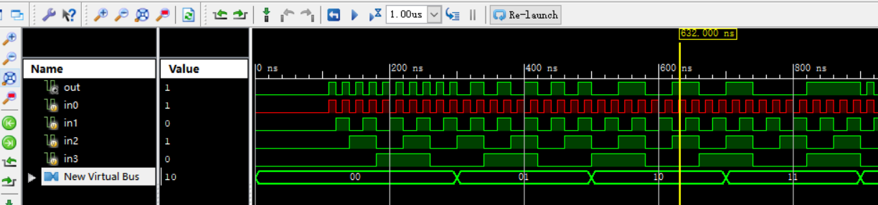

4选1 采用if语句 的第2种测试程序

initial begin
// Initialize Inputs
in0 = 0; in1 = 0; in2 = 0; in3 = 0;

// Wait 100 ns for global reset to finish
begin s0 = 0; s1 = 0; #10; repeat(10) #10 in0=~in0; end

begin s0 = 1; s1 = 0; #10; repeat(10) #20 in1=~in1; end

begin s0 = 0; s1 = 1; #10; repeat(10) #40 in2=~in2; end

begin s0 = 1; s1 = 1; #10; repeat(10) #80 in3=~in3; end

end

endmodule

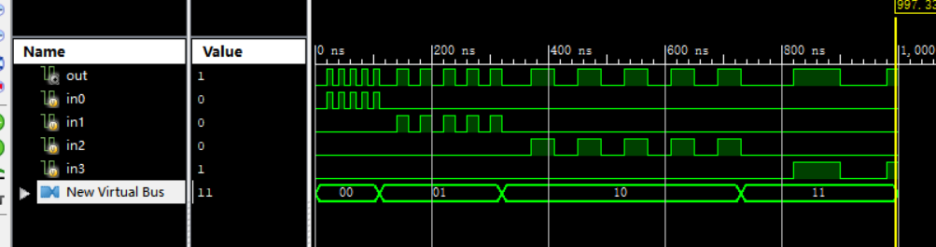

4选1 采用case语句 的源程序
`timescale 1ns / 1ps
module mux41_case
( input in0,in1,in2,in3,
input [1:0] s,
output out
);
reg temp;
always @*
begin
case (s)
2'b00: temp = in0;
2'b01:temp = in1;
2'b10:temp = in2;
default:temp = in3;
endcase
end
assign out=temp;
endmodule

4选1 采用case语句 测试程序

initial begin
// Initialize Inputs
in0 = 0; in1 = 0; in2 = 0; in3 = 0; s = 0;

// Wait 100 ns for global reset to finish
#100

// Add stimulus here

fork
repeat(160) #10 in0=~in0; //in0周期20ns
repeat(80) #20 in1=~in1; //in1周期40ns
repeat(40) #40 in2=~in2; //in2周期80ns
repeat(20) #80 in3=~in3; //in3周期160ns
repeat(10) #100 s=s+1;
//
join

end

Endmodule

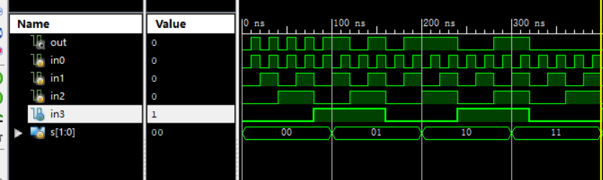

38译码器的源程序：

`timescale 1ns / 1ps
module decode_38(Din,Dout
);
input[2:0] Din;
output reg[7:0] Dout;
always@ (Din)
begin
case(Din)
3'b000: Dout <= 8'b11111110;
3'b001: Dout <= 8'b11111101;
3'b010: Dout <= 8'b11111011;
3'b011: Dout <= 8'b11110111;
3'b100: Dout <= 8'b11101111;
3'b101: Dout <= 8'b11011111;
3'b110: Dout <= 8'b10111111;
3'b111: Dout <= 8'b01111111;

default:Dout <= 8'b00000000;
endcase
end

endmodule

38译码器的测试程序：

initial begin
// Initialize Inputs
Din = 0;
// Wait 100 ns for global reset to finish
#100;
// Add stimulus here
#100; Din=3'b000;
#100; Din=3'b001;
#100; Din=3'b010;
#100; Din=3'b011;
#100; Din=3'b100;
#100; Din=3'b101;
#100; Din=3'b110;
#100; Din=3'b111;
end

endmodule

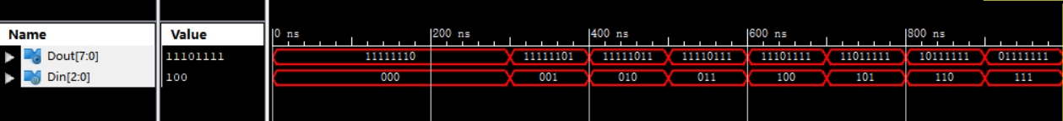

16进制计数器源程序：

`timescale 1ns / 1ps
module counter16(clk,rst_n,en, dout,co
);
input clk,rst_n,en;
output [3:0] dout;
reg [3:0] dout;
output co;
always @(posedge clk or negedge rst_n)
begin
if (!rst_n)
dout <= 4'b0000;
else if (en)
if (dout== 4'b1111)
dout <= 4'b0000;
else
dout <= dout +1'b1;
else
dout <=dout;
end

assign co=dout[0]&dout[1]&dout[2]&dout[3];

endmodule

16进制计数器测试程序：

initial begin
// Initialize Inputs
clk = 0;
rst_n = 0;
en = 1;

// Wait 100 ns for global reset to finish
#100;
rst_n = 1;
// Add stimulus here
forever #10 clk=~clk;

end

endmodule

